Alfredton School Charter and Annual Strategic Plan 2022
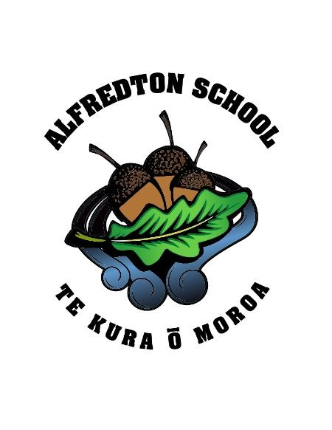
Inspiring learning for a lifetime - Little acorns to mighty oaks

Our Vision: To grow students to be confident, broad minded, innovative learners who are community orientated and culturally aware.
Our Values: To be MIGHTY Oaks – Motivated
Imaginative
Giving Respect
Happy
To be adaptable
You’re confident

General Description
Alfredton School is a rural U1, full primary. The school is 47 km north of Masterton and 19 km east of Eketahuna and is in an attractive rural setting (golf course alongside and the domain nearby). The pupil catchment area is approximately within a 23 km radius, with all of our children travelling to school on a Ministry Direct Resourced bus service operated by the school. The Alfredton District is mainly a beef and sheep farming area where a strong community spirit exists and both parents and the wider community are actively involved, interested and supportive of school life. The school fundraising team, ASCA, are the driving force behind the school’s fundraising and provide support for all major events. Our staff and Board of Trustees strive to provide a secure environment for children to learn and develop, for staff to grow professionally. They are committed to “Excellence in Education” and ensuring that the wellbeing of all children and staff is paramount in their policies and procedures.

Māori Dimensions and Cultural Diversity
Alfredton School ended 2021 with a roll of 45 students, with 25% of these students identifying as Māori. Our students come from a range of iwi. We recognise and respect the cultural diversity of all families at our school. The school promotes the importance of New Zealand’s cultural diversity and the unique position of Māori culture. This is demonstrated through:
- Consultation with our Māori community on charter development and student achievement.
- Policies and procedures that reflect New Zealand’s and Alfredton School’s community and cultural diversity.
- Providing all students with experiences and understanding in cultural traditions, language and local history.
- Visits by students and staff to local marae
- Enriching the NZ Curriculum with Māori Language and Māori cultural perspectives.
- Ensuring planning and teaching incorporates Te Ao Māori through Te Reo and Tikanga Māori.
The Board will consider any requests from parents for instruction to be delivered in Te Reo Māori and all reasonable steps will be taken to explore possibilities for extending the current provision e.g. dual enrolment with Te Kura, consulting with Māori Education Services, advising whanau of the nearest school that provides a higher level of instruction in Te Reo and Tikanga Māori (if available).

Focus Area 1: The Future of Teaching and Learning including Cultural Responsiveness and Localised Curriculum Design (NELP Objectives: 1, 2, 3, 4)
Objective / Action | How it will be achieved | Responsibility | Progress
To develop outdoor learning | Learning through Discovery / Play  Junior Room  - Designated outdoor area at the back of the classroom  - Develop water play, painting, small world, large construction, chalkboards etc  Loose Parts  - Designated outdoor area for use at break times or booked class time using tyres, tarp, planks of wood, buckets etc  Visits to Douglas Park School, Solway School, Forest School (Masterton) and Southend School (Carterton)  Possible PLD: Paula Jamieson Play, Make, Create, Longworth Education | Principal / Junior Room Teacher  All Staff  All Staff
To develop assessment and student agency | Introduce PACT as a system of whole school assessment  - Understand the Learning Progressions and how they impact on next steps for learning  PLD: Kahui Ako | Principal / All Staff
To develop Kaitiakitanga – Caring for our Environment | Native Garden and Wetland Project  - Restore the drain and seep back into the native habitat and grow its biodiversity  - Understand how the native trees they will plant and care for will contribute to cleaner waterways and promote biodiversity  - Create an aesthetically engaging natural space that serves the school community as an outdoor teaching and learning space and the wider community as a recreational space  Develop engagement with:  - Horizons Council Freshwater Team  - Ihuraua/Upper Tiraumea Catchment Group  - Local Iwi and Marae | Principal / All Staff /Community  Board
To develop Te Reo and Maori Tikanga within our curriculum | Introduce He Kakahu Reo across school in order to develop Maori identity, Te Reo and Maori Tikanga. (Work with Paul Anderson - DP Lakeview) | Principal / All Staff

Focus Area 2: Curriculum Development (NELP Objectives 1, 2, 3, 4)
Objective / Action | How it will be achieved | Responsibility | Progress
To develop an understanding of Learning Progressions and introduce PACT as a system of Assessment | All staff to understand and use learning progressions to plan and teach maths, writing and reading.  To use the learning progressions to inform assessment.  PLD via Kahui Ako | Principal
To Implement the Refreshed Curriculum, ensuring all students have agency | 2022: Aotearoa Histories  Ensure staff have an understanding of the new curriculum  Develop a resource bank  Investigate how local history can support the new curriculum | Principal / All Staff / Community
Writing  To raise the achievement of all students and close the gap for our Māori learners and children who have been identified as priority learners | PLD: Murray Gadd - improving writing achievement  Embed and further develop Big Writing throughout the school and The Write Stuff in the Senior Room  Use of co-constructed success criteria to enable students to self-assess learning  Implement a spelling program  Use of intervention programs with identified priority learners. These will be reviewed termly. | Principal / Literacy Lead Teacher / All Staff  Teacher Aide / All Staff
Reading  To further develop links with whanau and increase reading mileage for the children | Whole School Reading Diaries with all students expected to use them.  Further develop the Home Reading Program.  Invite whanau / community members to share their reading with students / read aloud to younger students | Principal / Literacy Lead Teacher
Maths  To embed maths progressions and develop self-assessment grids to promote student agency and understanding of learning progressions | Use of co-constructed success criteria to enable students to self-assess learning  Further develop teaching of ‘strand’ alongside number in the Senior Room  To begin to introduce STEM using Epro8 and Arduino with Senior students | All Staff

Focus Area 3: To Re-imagine our Vision and School Values (NELP Objective 1)
Objective / Action | How it will be achieved | Responsibility | Progress
To revisit our Vision and Values as we redesign our curriculum to meet the needs of all learners | Consult with staff, students and community  Working Party comprising of all stakeholders to create a re-imagined vision and school values | Principal / Board / All Staff

